**Letter Requesting a Recommendation**

**Overview**

A [letter of recommendation](http://www.wikihow.com/Sample/Personal-Recommendation) is written by someone who knows you and can describe your experience, skills, and character. The recommendation is useful for getting a job or scholarship. For the Capstone project you need at least two letters of recommendation. To obtain them you need to write a letter requesting a recommendation from someone like an employer, mentor, teacher, coach, or counselor.

**What to Include**

Keep the letter requesting a recommendation brief. Let the person know what the purpose of the the recommendation is. For instance to apply for a job or scholarship. Mention what your career, job, or educational goal is which the letter will help obtain. Suggest key characteristics and abilities of yours for the person to include as supporting details. Let the person know when you need the letter by. Give them about two weeks to write it. Finally thank the person for considering your request.

**Structure**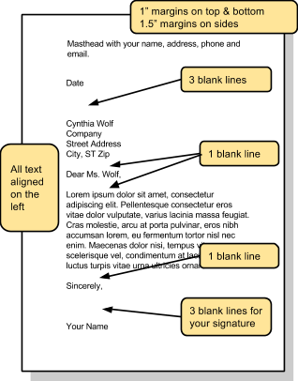

Format the letter using a block style which is popular for business correspondence. Address it to the person who you want to write the recommendation. To the right is the structure. Here is a [video tutorial](https://drive.google.com/file/d/0B-tZ4-fot0SrbF9XUVFkR29IU0E/view?usp=sharing) with one way to set up the masthead.

**Finalize**

Have someone read your rough draft and give you feedback on its effectiveness, grammar and spelling. Write the final

version and print it. Make sure and hand sign the letter in ink before sending it.